**ASSIGNMENT 2 FRONT SHEET**

|  |  |  |  |
| --- | --- | --- | --- |
| **Qualification** | **BTEC Level 5 HND Diploma in Computing** | | |
| **Unit number and title** | 10: Website Design & Development | | |
| **Submission date** | December 25 2022 | **Date Received 1st submission** |  |
| **Re-submission Date** | January 5 2023 | **Date Received 2nd submission** |  |
| **Student Name** | Dang Ngo Dai Hanh | **Student ID** | GCC210154 |
| **Class** | GCC1002 | **Assessor name** | Tran Thi Kim Khanh |
| **Student declaration**  I certify that the assignment submission is entirely my own work and I fully understand the consequences of plagiarism. I understand that making a false declaration is a form of malpractice. | | | |
|  |  | **Student’s signature** | Hanh |

**Grading grid**

|  |  |  |  |  |  |  |
| --- | --- | --- | --- | --- | --- | --- |
| P5 | P6 | P7 | M4 | M5 | D2 | D3 |
|  |  |  |  |  |  |  |

|  |  |  |
| --- | --- | --- |
| **❒ Summative Feedback: ❒ Resubmission Feedback:** | | |
| **Grade:** | **Assessor Signature:** | **Date:** |
| **Signature & Date:** | | |
|  | | |

Assignment Brief 2 (RQF)

Higher National Certificate/Diploma in Computing

|  |  |
| --- | --- |
| **Student Name/ID Number:** |  |
| **Unit Number and Title:** | **Unit 10: Website Design & Development** |
| **Academic Year:** | **2021 – 2022** |
| **Unit Assessor:** | **Hoang Nhu Vinh** |
| **Assignment Title:** | **Website Design and Implementation** |
| **Issue Date:** | **01 April 2021** |
| **Submission Date:** |  |
| **Internal Verifier Name:** |  |
| **Date:** |  |

|  |
| --- |
| **Submission Format:** |
| *Format:*   1. A report document including below sections    * Section 1: A review of appreciate web design principles, standards and guidelines.    * Section 2: Design document for online shopping website.    * Section 3: Implementation of website design.    * Section 4: Test plan and test evaluation. 2. A compressed file that encapsulates all source code and particular necessary resources including files of images, style sheets, java script and other files to support to install multipage website such as sql script and installation guide.   *Submission*   * Students are compulsory to submit the assignment in due date and in a way requested by the Tutor. * The form of submission will be a soft copy posted on [http://cms.greenwich.edu.vn/.](http://cms.greenwich.edu.vn/) * Remember to convert the word file into PDF file before the submission on CMS.   *Note:*   * The individual Assignment *must* be your own work, and not copied by or from another student. * If you use ideas, quotes or data (such as diagrams) from books, journals or other sources, you must reference your sources, using the Harvard style. * Make sure that you understand and follow the guidelines to avoid plagiarism. Failure to comply this requirement will result in a failed assignment. |

|  |
| --- |
| **Unit Learning Outcomes:** |
| **LO3** Utilise website technologies, tools and techniques with good design principles to create a multipage website.  **LO4** Create and use a Test Plan to review the performance and design of a multipage website. |
| **Assignment Brief and Guidance:** |
| **Assignment scenario**  You currently work for a software training company that produces courses and topic presentations to established companies and, importantly, to new start-ups. MWS wishes to pursue a bespoke web-based e-commerce solution. MWS were impressed with your presentations and wishes to continue with the design and development of an e-commerce website.  A sister company develops web solutions and you have been tasked with taking the lead on the MWS solution you outlined previously.  You are now required to design and create an interactive website with the emphasis being on the production of a set of simple dynamic web pages, which embody good design principles. The site will be themed around a template which would be most appropriate to MWS, with placeholders for text and content. Images and icons will be used, to give MWS a feel for the proposed website design. You will also include a membership area, where users can register to have access to restricted areas.  You will base on *MWS-CaseStudy.docx* for more information. |

|  |  |  |  |
| --- | --- | --- | --- |
| **Learning Outcomes and Assessment Criteria (Assignment 2):** | | | |
| Learning Outcome | Pass | Merit | Distinction |
| LO3 | **P5** Create a design document for a branded, multipage website supported with medium fidelity wireframes and a full set of client and user requirements. | **M4** Compare and contrast the multipage website created to the design document. | **D2** Critically evaluate the design and development process against your design document and analyse any technical challenges. |
|  | **P6** Use your design document with appropriate principles, standards and guidelines to produce a branded, multipage website supported with realistic content. |  |  |
| LO4 | **P7** Create a suitable Test Plan identifying key performance area and use it to review the functionality and performance of your website. User Experience (UX) and User Interface (UI). | **M5** Evaluate the Quality Assurance (QA) process and review how it was implemented during your design and development stages. | **D3** Critically evaluate the results of your Test Plan and include a review of the overall success of your multipage website; use this evaluation to explain any areas of success and provide justified |
|  |  |  | recommendations for areas that require improvement. |

Table of Contents

I. A REVIEW OF APPRECIATE WEB DESIGN PRINCIPLES, STANDARDS AND GUIDELINES 6

1. **Principles for a good website design 6**

**2.** **Web design Standards** 7

**3.** **Web design guideline** 8

I. DESIGN PLAN (P5) 9

**1. Users’ Requirements** 9

**2. Users** 9

**3. Input provide by the Client** 10

**4. Scope of the Work 10**

**5. Customer Acceptance Criteria 10**

**6. Architecture of the Application 11**

**7. Wire frames and specific explanation 14**

II. WEBSITE IMPLEMENTATION (P6) 17

**1.** **Functional screen shot after implementation** 17

III. TESTING 27

**1.** **Test plan** 27

References 31

# I. A REVIEW OF APPRECIATE WEB DESIGN PRINCIPLES, STANDARDS AND GUIDELINES

## 1.Principles for a good website design

* **Alignment**

Align or alignment is a term that describes how text is placed on the screen. For example, left-aligned text creates a straight line of text on the left side of the page (like this paragraph). Text can be aligned along the edge of a page, cell, div, table, or another visible or non-visible line. Below are some different examples of aligned text. (ComputerHope, 2020)

* **80/20**

The 80-20 rule or Pareto Principle is a phenomenon primarily used in business and economics that explains how 20% of efforts or inputs can yield 80% of results or outputs. It helps identify and focus on the crucial factors to create maximum value while delegating the least important ones. (Team, 2022)

* **Whitespace**

White space, also referred to as negative space, is all the space on your website which isn’t actively filled with design elements or objects. Whilst it’s essentially devoid of actual design objects, white space is vitally important in creating professional website designs. White space is the space between graphics, margins, columns, copy and other visuals. It allows a page to ‘breathe’ and design elements to exist on the page. Websites which exclude white or negative space will look cramped and can be very hard to understand or read. The correct use of white space also helps bring an element of elegance or sophistication and improves legibility and user experience. (Atelierstudios, 2019)

* **Colour/highlighting**

Colour has the power to communicate messages and evoke emotional responses. Finding a colour palette that fits your brand will allow you to influence your customer’s behaviour towards your brand. Keep the colour selection limited to less than 5 colours. Complementary colours work very well. Pleasing colour combinations increase customer engagement and make the user feel good. (Marianne, 2021)

* **Organisation**

Provide the user with a clear and consistent conceptual structure. Consistency, screen layout, relationships and navigability are important concepts of organization. (Martin, 2022)

* **Symmetry**

According to Merriam-Webster, “symmetry” is defined as “balanced proportions” or “beauty of form arising from balanced proportions.” It also defines being symmetrical as having “correspondence in size, shape, and relative position of parts on opposite sides of a dividing line or median plane or about a center or axis.”

This balance can often be aesthetically pleasing. It evens out the “visual weight” of an image so our eyes are not drawn to one element or area in particular. And it helps us quickly absorb and make sense of visual information.

“Balancing a composition involves arranging both positive elements and negative space in such a way that no one area of the design overpowers other areas,” Steven Bradley wrote for Smashing Magazine. “Everything works together and fits together in a seamless whole. The individual parts contribute to their sum but don’t try to become the sum.” (Canva, 2022)

* **Consistency.**

Design Consistency is a quality associated with things that are the same from time to time, meaning that they always behave or perform in a similar way. In terms of user experience design, it is synonymous with familiarity and predictability. Consistency can make an interface more intuitive because the user knows how a particular element will work, look and feel in all situations. For example, an address bar on a website will usually be present at the top of the page. In this case, there is consistency as it is always present in the same place and therefore predictable for the user. The sense of harmony they create increases interaction – they spark interest, raise satisfaction and eventually build loyalty.

As Jakob Nielsen defined it, consistency is about “enforcing the user’s expectations,” and keeping the user-oriented through a minimalistic approach that keeps common UI elements grouped in one place. (Uikit, 2022)

1. **Web design Standards**

Web Design and Applications involve the standards for building and Rendering Web pages, including HTML, CSS, SVG, device APIs, and other technologies for Web Applications (“WebApps”). This section also includes information on how to make pages accessible to people with disabilities (WCAG), to internationalize them, and make them work on mobile devices.

* **HTML & CSS Header link**

HTML and CSS are the fundamental technologies for building Web pages: HTML (html and xhtml) for structure, CSS for style and layout, including WebFonts. Find resources for good Web page design as well as helpful tools.

* **JavaScript Web APIs Header link**

Standard APIs for client-side Web Application development include those for Geolocation, XMLHttpRequest, and mobile widgets. W3C standards for document models (the “DOM”) and technologies such as XBL allow content providers to create interactive documents through scripting

* **Graphics Header link**

W3C is the home of the widely deployed PNG raster format, SVG vector format, and the Canvas API. WebCGM is a more specialized format used, for example, in the fields of automotive engineering, aeronautics.

* **Audio and Video Header link**

Some of the W3C formats that enable authoring audio and video presentations include HTML, SVG, and SMIL (for synchronization). W3C is also working on a timed text format for captioning and other applications.

* **Accessibility Header link**

W3C’s Web Accessibility Initiative (WAI) has published Web Content Accessibility Guidelines (WCAG) to help authors create content that is accessible to people with disabilities. WAI-ARIA gives authors more tools to create accessible Web Applications by providing additional semantics about widgets and behaviors.

* **Internationalization Header link**

W3C has a mission to design technology that works across cultures and languages. W3C standards such as HTML and XML are built on Unicode, for instance. In addition, W3C has published guidance for authors related to language tags bi-directional (bidi) text, and more.

* **Mobile Web Header link**

W3C promotes “One Web” that is available on any device. W3C’s Mobile Web Best Practices help authors understand how to create content that provides a reasonable experience on a wide variety of devices, contexts, and locations.

* **Privacy Header link**

The Web is a powerful tool for communications and transactions of all sorts. It is important to consider privacy and security implications of the Web as part of technology design. Learn more about tracking and Web App security.

* **Math on the Web Header link**

Mathematics and formula are used on the Web for business reports, education materials and scientific research. W3C’s MathML enables mathematics to be served, received, and processed on the World Wide Web, just as HTML has enabled this functionality for other types of content.

(W3, 2022)

1. **Web design guideline**

**Guidelines for web design and developers**

For designing a website, website designers require various techniques and guidelines. They can create a good website by following these guidelines. Custom web development software helps the web designer to easily create a website.

Below are the guidelines to keep in mind while designing a website:

* **Immediate Page Loading**

Visitors never wait with patience for a website to load. If your website is slow and takes a long time to open then it can’t be considered as an ideal website. Therefore, design your website by using quick loading rates. High conversion rate is another benefit of designing a fast-loading website.

* **Mobile- Friendly**

In the world of smartphones, ensure that you create a mobile-friendly website. Designing a responsive website that loads perfectly on any mobile is the best way to win the user response.

* **Responsive designs**

Responsive design is the contrast of programming and device which is difficult to add after a specific website is designed. It is mainly a part of a redesign. That is why it is a compact, not a Company standard. Responsive design has been regularly changed over the years.

* **Analyze conversion rate**

A successful website is successful which creates by analyzing the business goals. Therefore, it is recommended to develop a website to determine the goals of the business. It will help to know about the number of visitors, user engagement track, conversion rate, etc.

* **SEO- Friendly**

Web designers ensure that the website is SEO friendly. It means to develop your website keeping in mind the On-page SEO elements. Also, modify your website with SEO techniques. They can use XML sitemap and schema for SEO-friendly website. It helps to rank your website on top of Google’s result engine page.

* **Content Management System**

To provide strong digital marketing energy to your website, publish the unique and attractive content at your website so that customers get attracted. This will help the customer to be updated.

* **Social Media Integration**

Social media sites are integrated with your website. This will help visitors to look on social media pages directly from the website. It helps in attracting traffic and engaging visitors. Custom web development software helps to integrate your social media accounts with a website.

* **Provide on-site Security**

Online security is a must. Web designers need to be considered while developing a website. The designs should provide important security checks. Using significant safety and privacy etiquette, they can able to provide safety to the website from hackers

* **Search feature**

A website must have a search feature. Many marketing sites don’t have a search feature. It appears globally on the page as an icon or search box. Search feature should be on the header of the page.

* **Impressive home page**

The home page of your website has a specific value proposition. It should be impressive and attractive. The home page with high-value proposition means that your website explains their value to the viewers.

So, these are top web design and development guidelines for 2019 that should be kept in mind while designing website. Creating a simple, user-friendly and secure website are the keys to business success. The guidelines will surely attract visitors.

Custom web development services are important to create a customized website. It is designed to determine the goals of a business.

(Agrawal, 2019)

**I. DESIGN PLAN (P5)**

**1. Users’ Requirements**

* **Project Specification**

Petshop.com is an online store that sells pet food. They have a lot of different types of food. Now they want to improve their website with all the products listed on the site. Buyers will easily view different products and decide to buy the right product that meets their requirements. When customers want to buy a certain product, they will first go to the homepage of the website and then click on that product to see detailed information about the product. The website should be designed with a shopping cart that allows customers to add the pet food they want to buy to the basket, as well as product information and product catalog information. When you want to add an item to the cart, the website requires customers to log in to their account to be able to select the items they want to buy and add to the cart. If the customer does not have an account, then select the register button, after successful registration, the customer can log in again to be able to add products to the cart. When on the homepage of the website, this is where all the products of the store are displayed, where the user will see the store's logo, and the product catalog in the store, sign in and sign out buttons. Customers can view and buy products that suit their needs. Customers can also log in, register and log out, or search for information related to the products they want, view product catalogs on the navigation bar, and view details and prices.

The website will be created for the Windows platform using MySQL and PHP.

**2. Users**

Company: Petshop staff are online staff to advise customers, managers and staff on site.

Customer: Users or maybe the majority are students, animal lover

**3. Input provide by the Client**

Company: Petshop staff are online staff to advise customers, managers and staff on site

Customer: Users or maybe the majority are students, who love junk food and want to buy it

**• Input data is taken from the Users which data is put into the system**

- Information about pet food category: Category ID, Category Name

- Information about pet food: product ID, product Name, product Price, product Status, product Image, product description, product quantity.

- Customer information: username, password, full name, phone number, email, date of birth, gender.

**• Output data is displayed to the user which data is taken from the system**

- List product Category.

- List all product and product detail.

- Searching

**• The processes of the system Processes are involved in the system**

- Processing customer’s registration.

- Processing customer’s login.

- Processing customer’s logout.

- Processing adds, edit, delete product type.

## 4. Scope of the Work

- Design a website for online shopping with multi pages: home page, cart page, detail page, search page, bill page, profile page, update profile page.

- The website is designed with a simple interface that is easy to use, the audience that the website wants to target is students, pet owners and especially volunteers working at abandoned pet camps.

- Front-end: The features of the customer:

* Users can register an account and log in with their registered email to purchase products.
* Users can search all products, search by product name.
* User can search by product category.
* User can view all products.
* User can view the product's detail page.
* User can add products to cart.
* User can buy the products.

- Back-end: Features with which the system handles user requests

* The system may encounter an error when the user registers.
* The system can check if the account exists when logging in
* The system will take the user's search information to display the corresponding product.
* When the user clicks on the logo, the system will redirect to the homepage.
* When the user selects any product, the system will lead to a detailed page about that product.
* When the user selects the product category, the system will lead to information related to the selected product category.
* When user click add to cart, the product will be added and the total amount of the selected product will be calculated.

The website has some admin functions, but the site is currently not authorized.

## 5. Customer Acceptance Criteria

|  |  |
| --- | --- |
| No. | Customer Acceptance Criteria |
| 1 | ­ Customers can register for a member account of the website and then log in to the website. |
| 2 | The website is designed to have a logo on the left side in the page header. |
| 3 | The site must contain links to navigate through a variety of dog or cat foods. |
| 4 | The site runs in browsers like google chrome, etc. |
| 5 | Administrators can perform the function: add, edit, delete product type. |
| 6 | Product information and prices are also included with the image. |
| 7 | The website is run on google chrome browser. |
| 8 | When the user login needs to have the email and password registered in the website, if the user is missing either one, the message "Please enter your info!!" will be displayed. |
| 9 | The administrator can perform the functions of adding, editing, and deleting product categories. |
| 10 | Admin can perform the functions of adding, editing, deleting products. |

1. **Architecture of the Application**

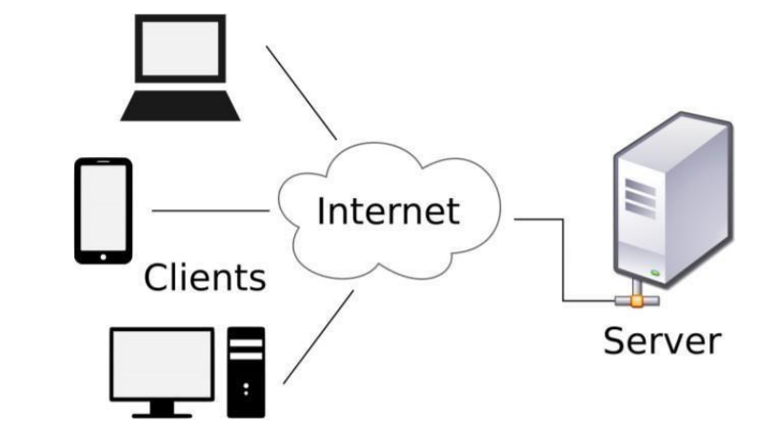

* Data Flow diagram

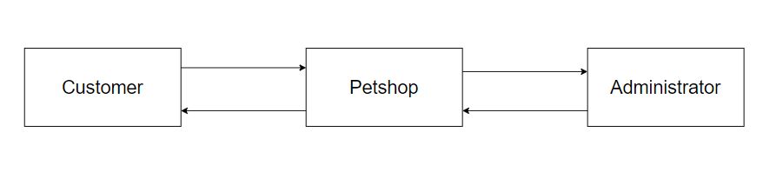

* Use case diagram

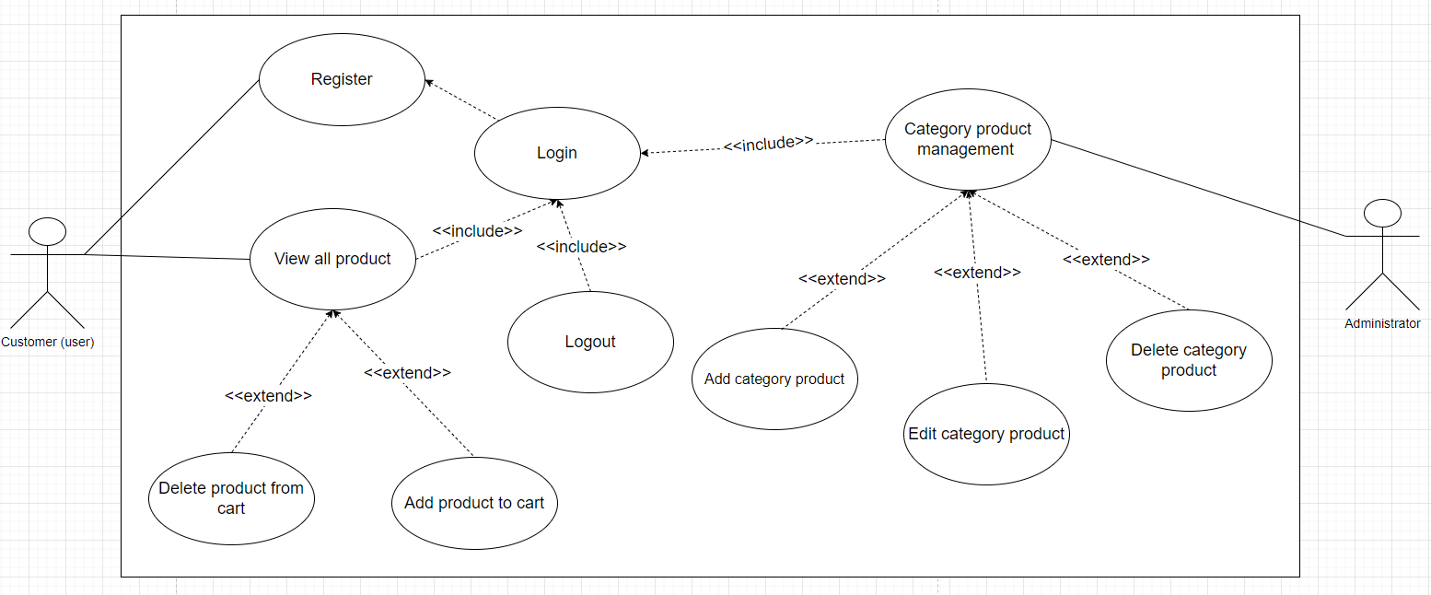

* Database diagram

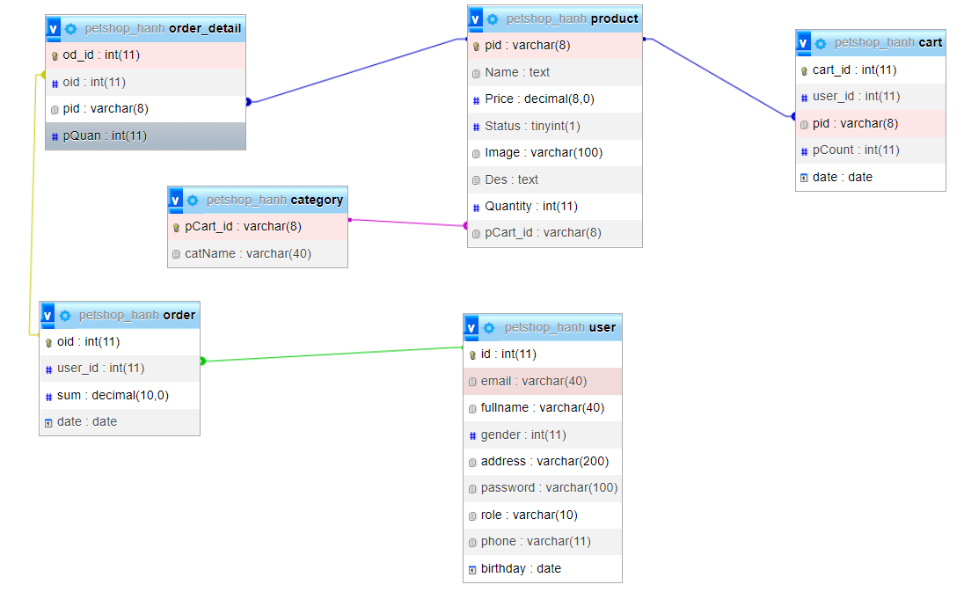

* Site map

- When user not login

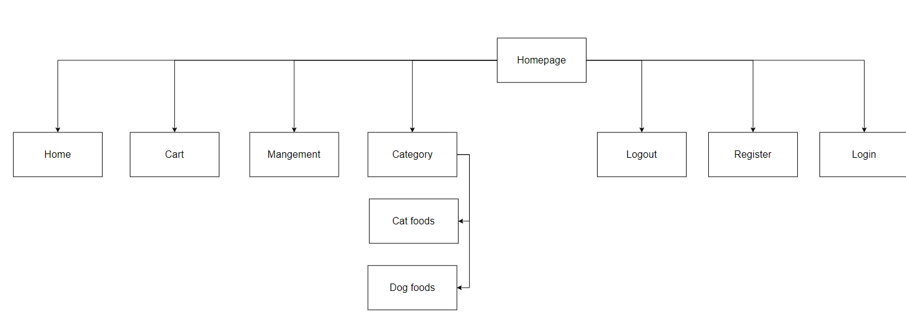

- When user login

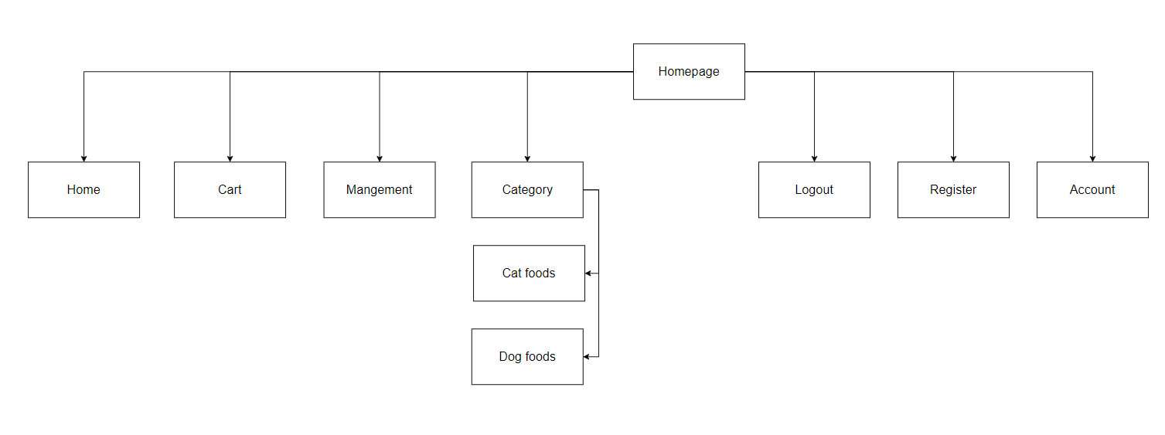

## 7. Wire frames and specific explanation

* Wire frames index

­­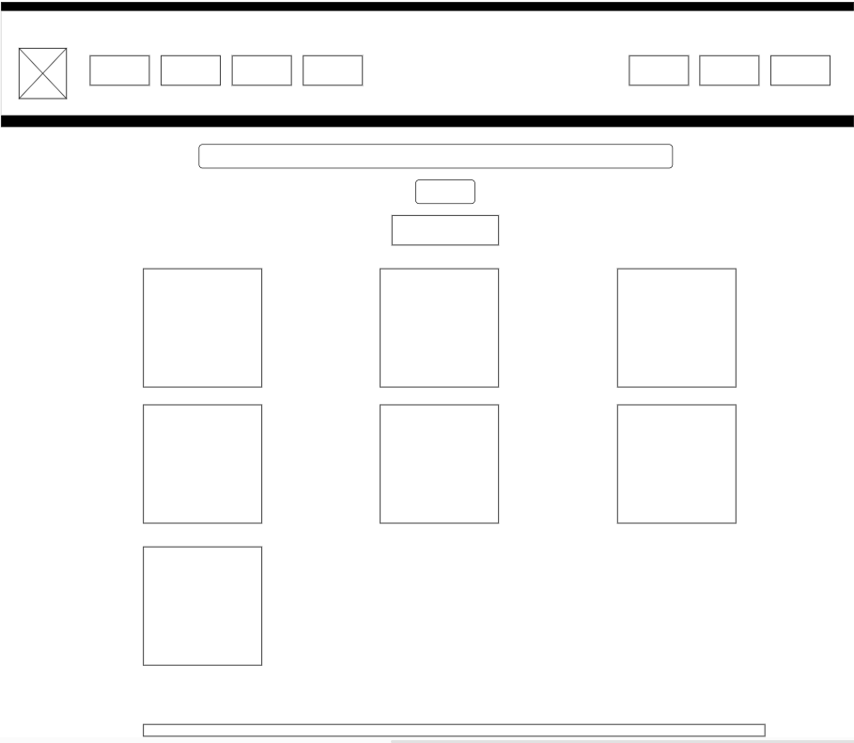

* Wire frames login

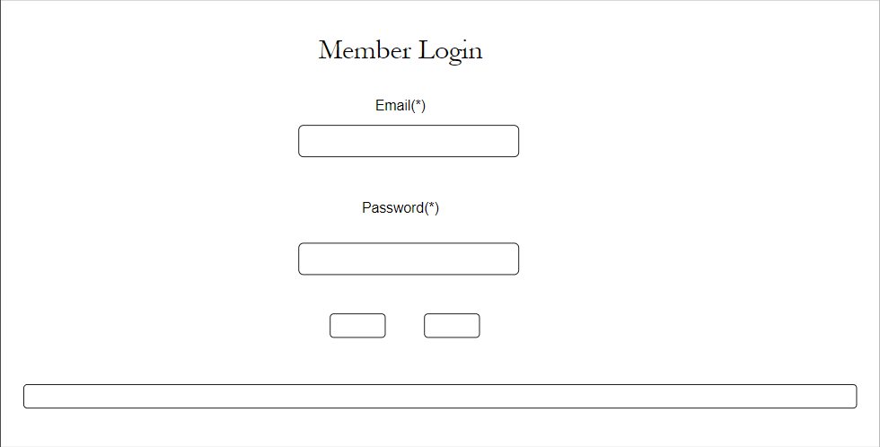

* Wire frames register

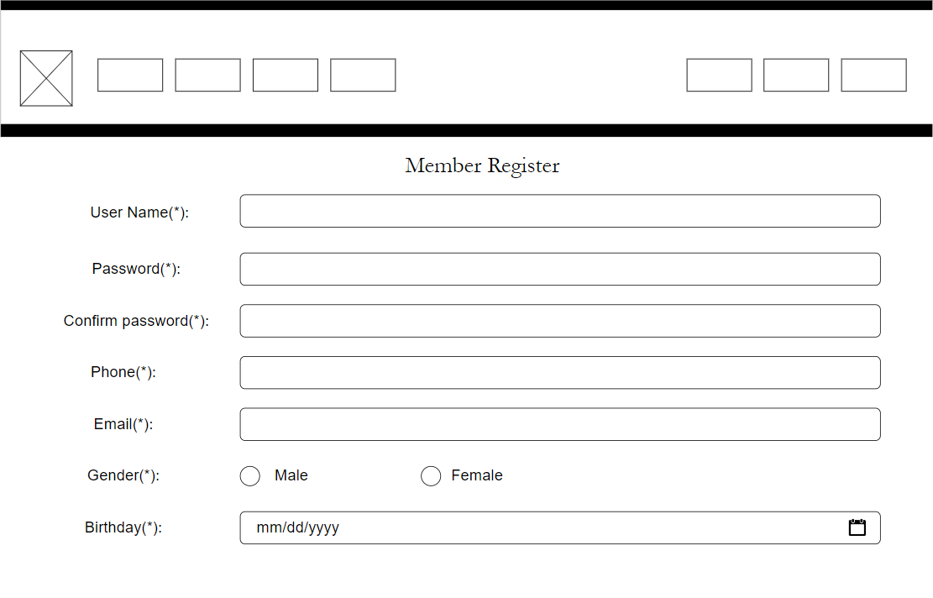

* Wire frames add category

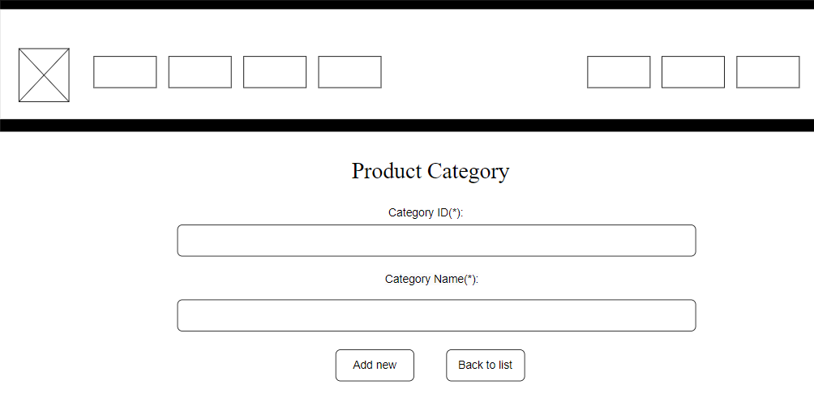

* Wire frames edit category

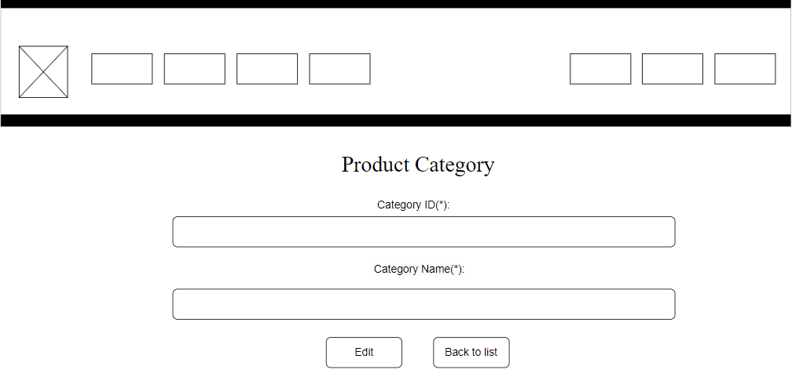

* Wire frames detail

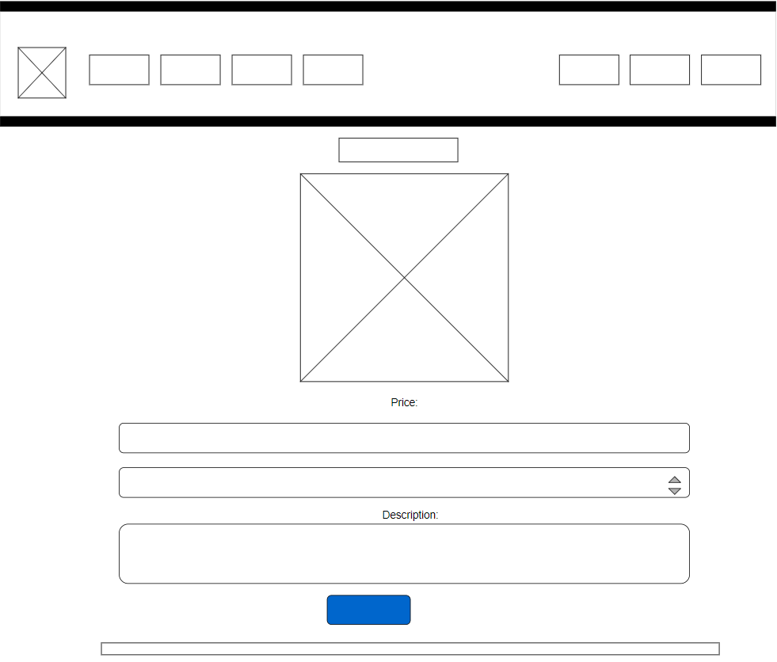

According to Wireframes, the title includes the shop's logo picture, login and register an account. For users, the navigation bar includes embedded bars associated with the product. And there is a management page for administrators to add, edit, and delete products. Pictures of the store and goods are displayed in the content section and the pgoor items turn in the store.

# II. WEBSITE IMPLEMENTATION (P6)

1. **Functional screen shot after implementation**

* Home page

On the homepage, above the customer can view the shopping cart, filter by category and login to the website, if the user does not have an account, they can register for an account and then log in to the website. Below is a display of all products.

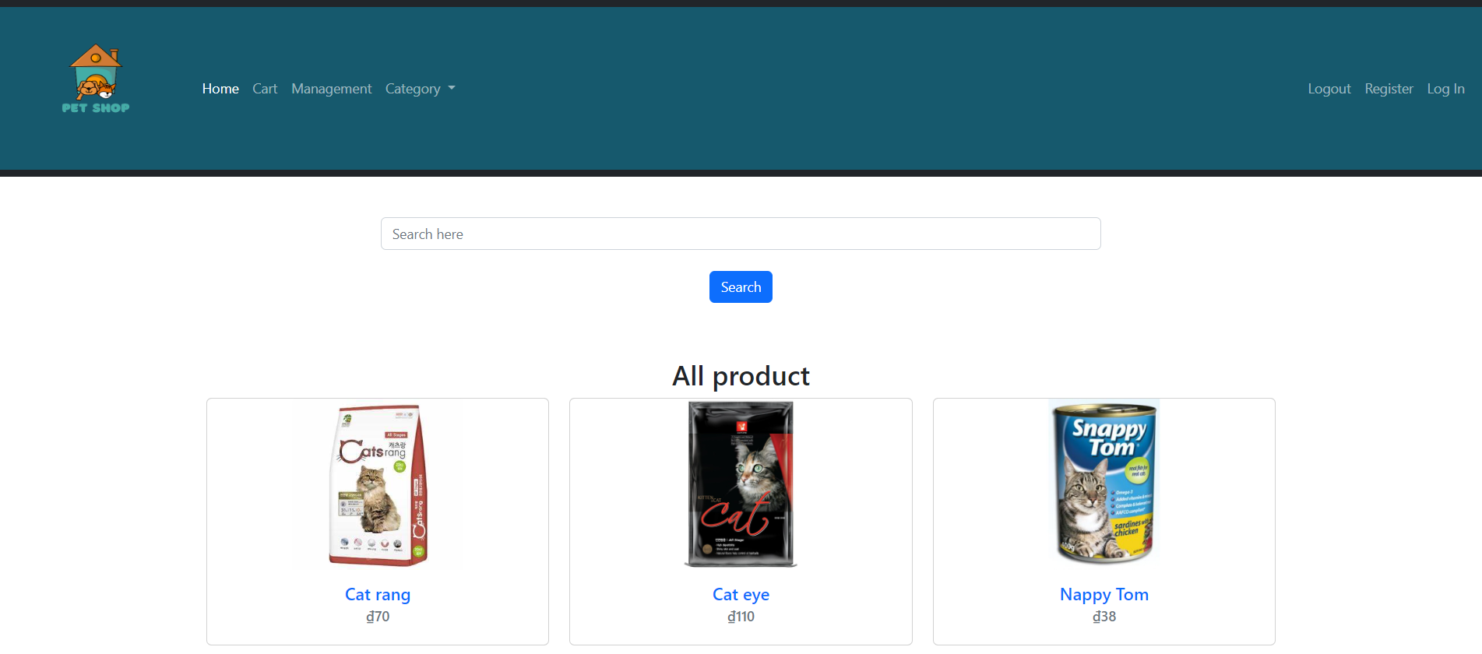

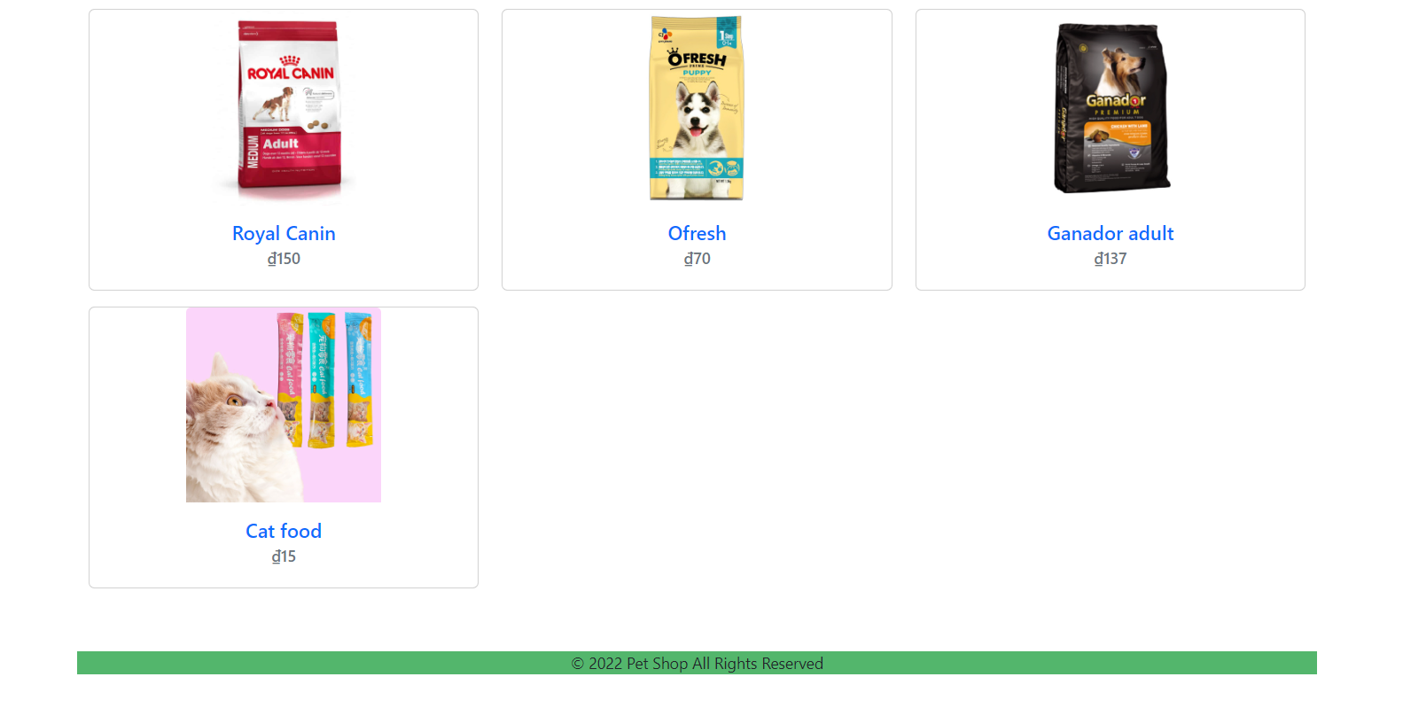

* Register

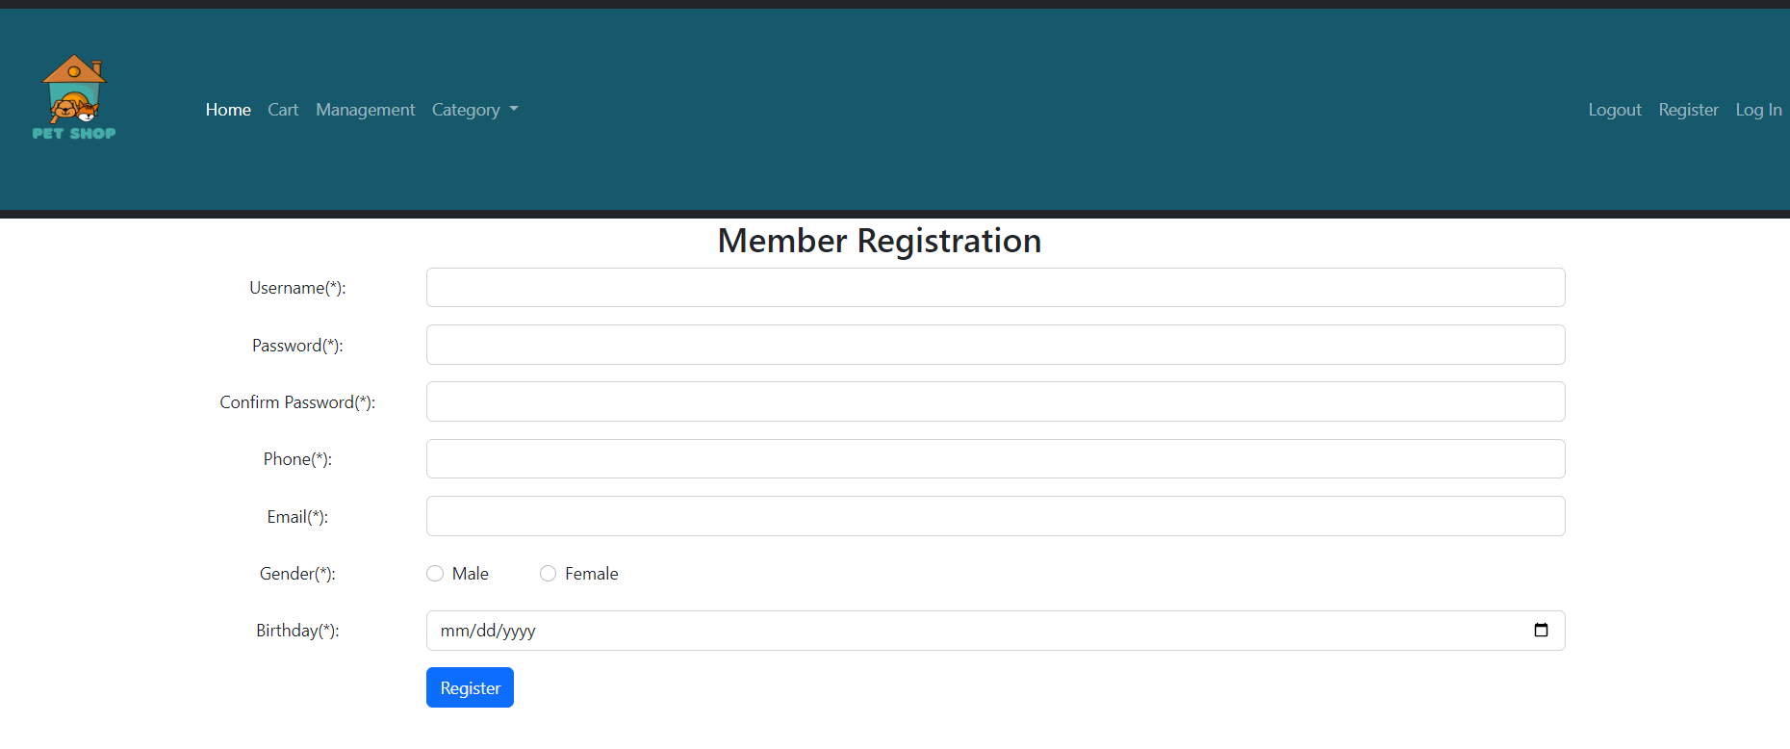

The registration page is where customers can register an account to log in to the website. The registration page includes username, password, password confirmation, phone number, email, gender, birthday. To create an account, users need to enter their full information and then click the register button. On successful registration, the text "congratulations!" will be displayed.

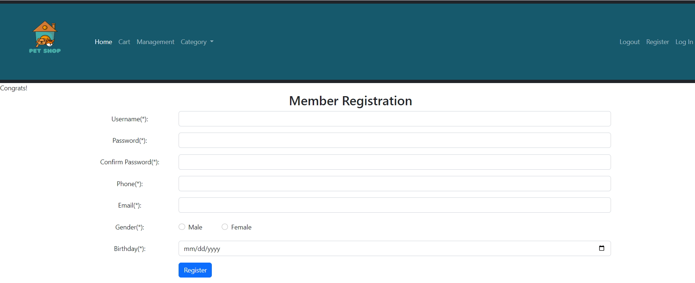

After successful registration, users can click on the word login at the top right of the website to log in

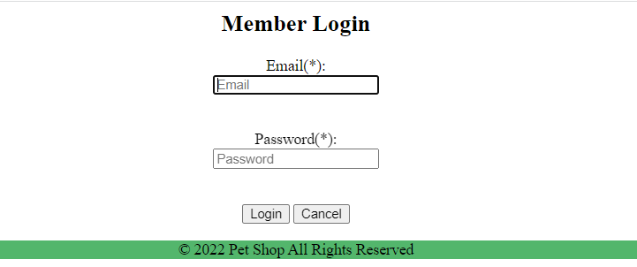

When the user enters the wrong account information, the website will display “something wrong with your info”

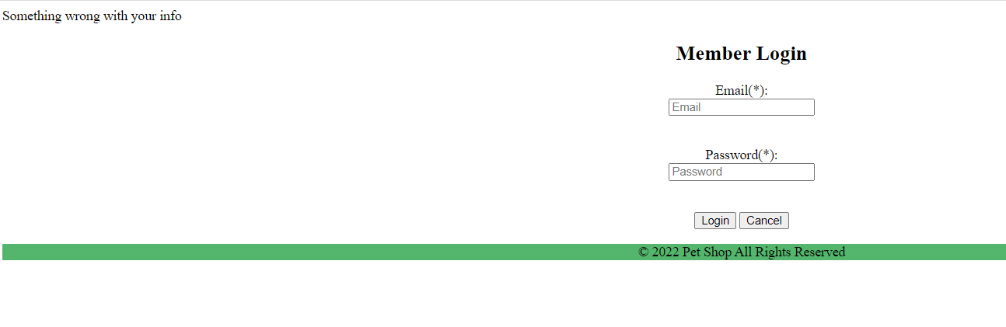

When the user is logged in with the correct registered account, the website will display the customer's username

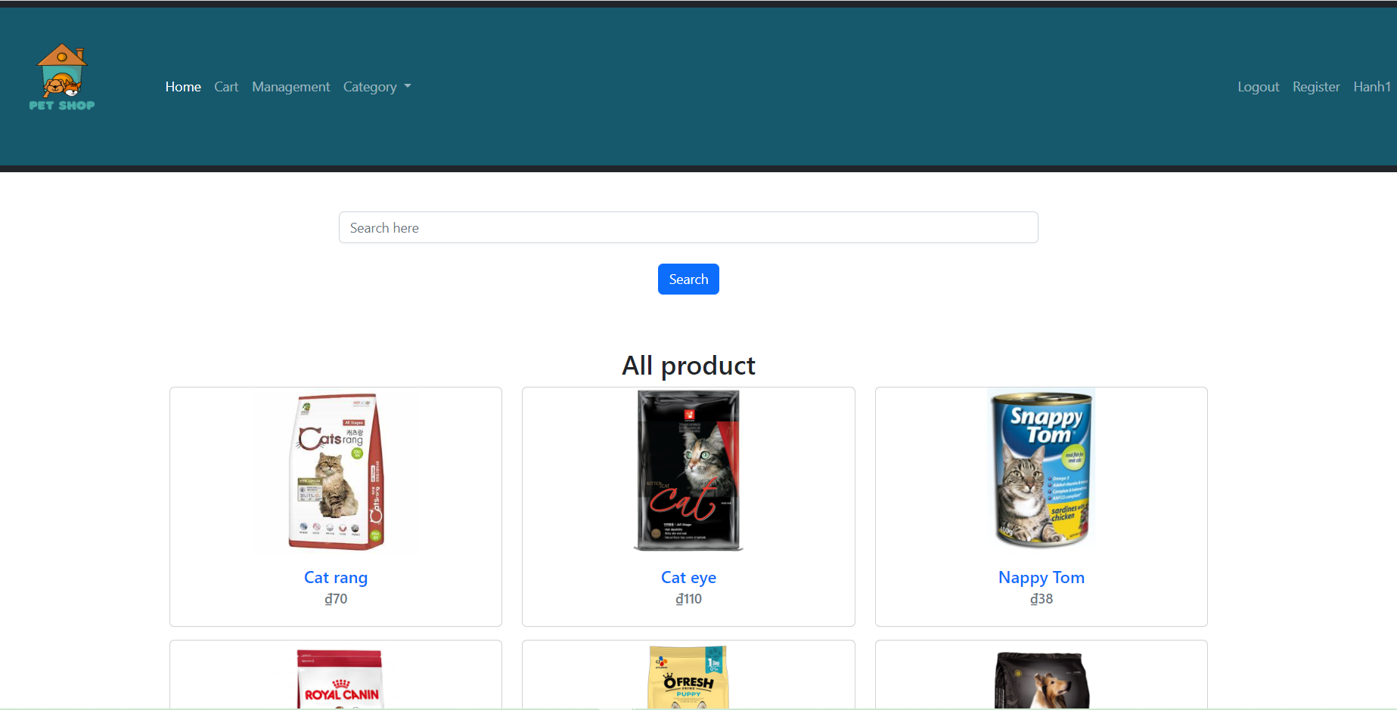

* Category management page

The product management page is where the admin can manage all the products on the site. Admin can add product category by clicking "Add" button and edit information by clicking on "edit" column or delete product category by clicking on "delete" column.

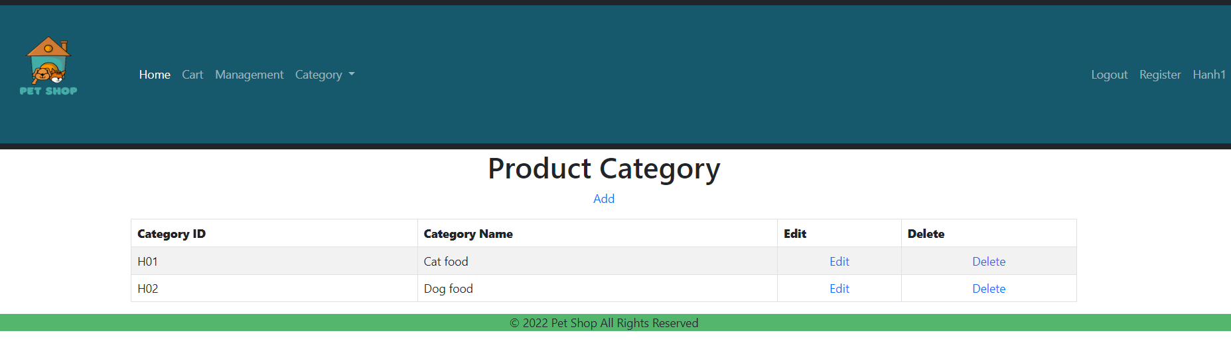

* Adding product category

In the add product category page, admin will add category ID and category name then click "Add new" button, if don't want to add admin can press "Back to list" button the website will redirect to the category management page, which immediately allows the administrator to terminate the procedure.

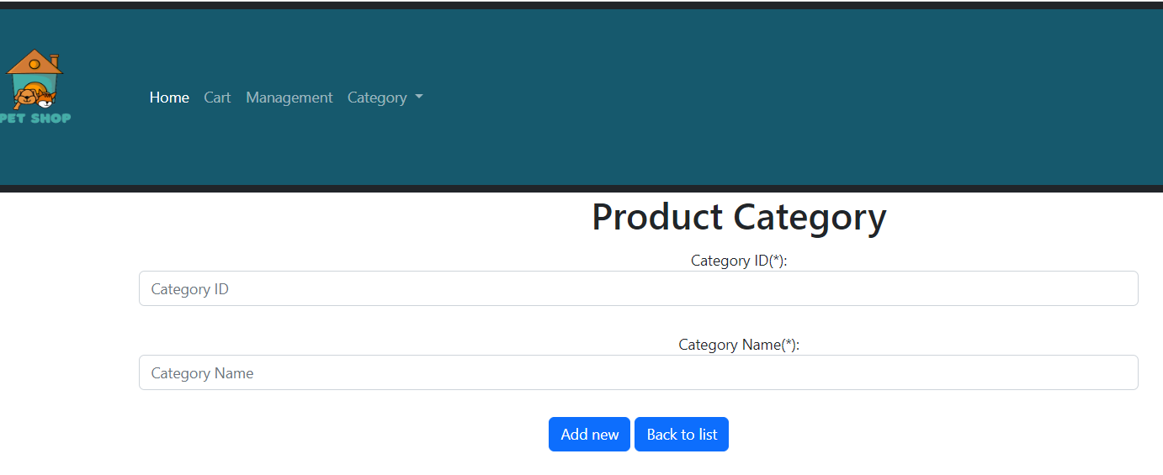

When adding product category successfully

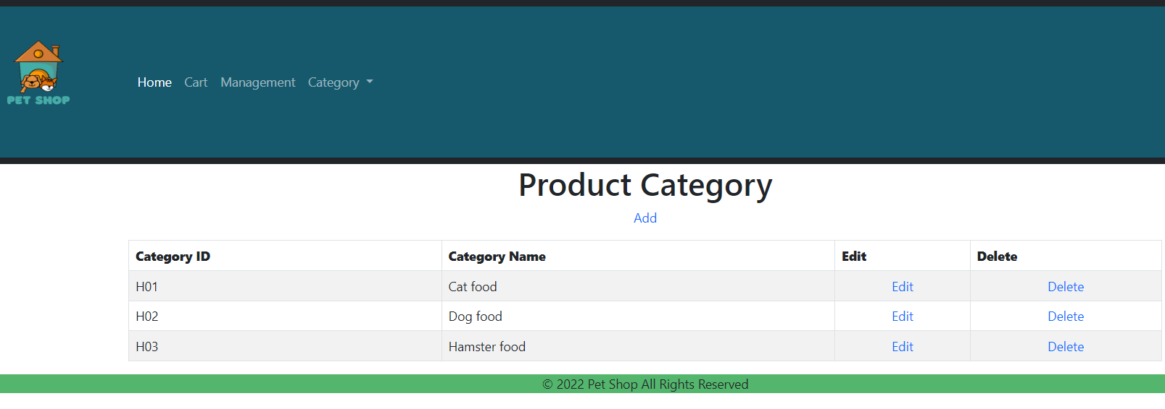

* Edit product category page

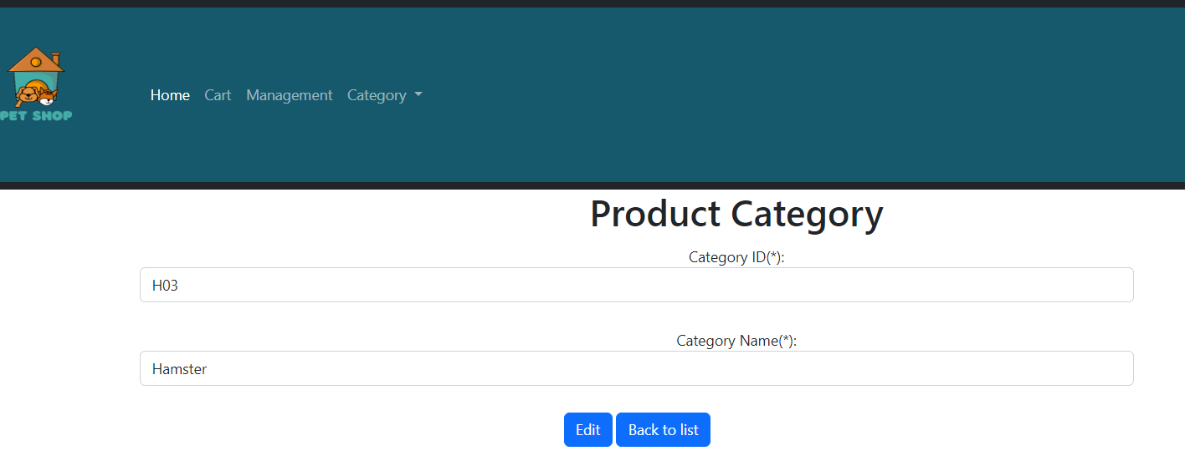

The admin can edit the category name, after the admin fills in the information they want to change, click the "Edit" button. Administrators can return to the product catalog management page by clicking "Back to list" if they do not want to make changes.

When edit is succesfull

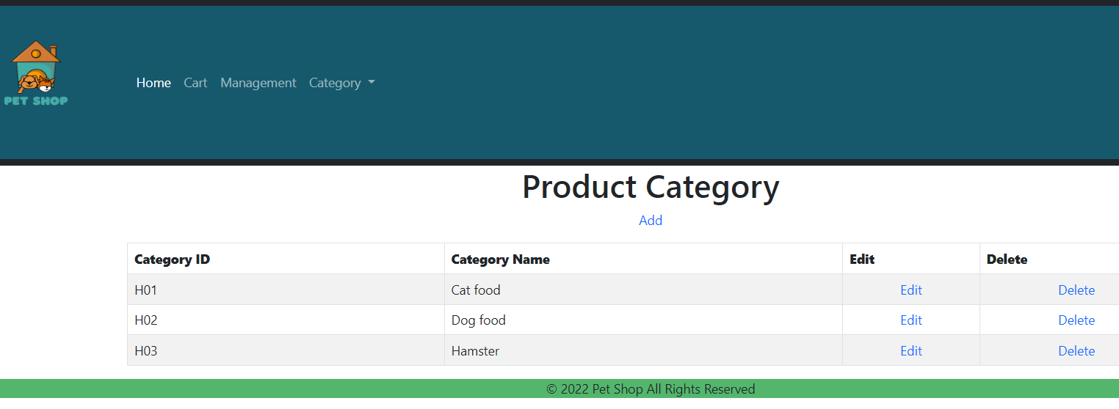

* Delete category page:

When the administrator wants to delete any category, the administrator can click "delete"



When delete is susscesfull

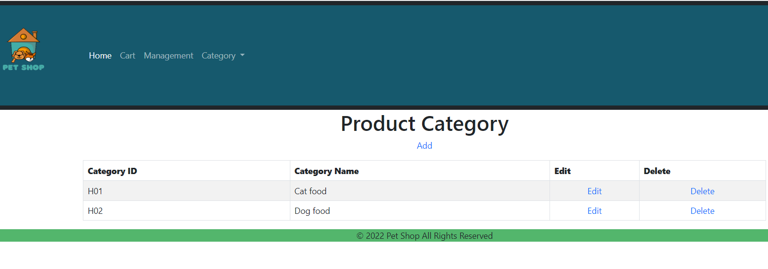

* Search products

When the user wants to search for a product, the user enters the search term and all the products matching that word will be displayed.

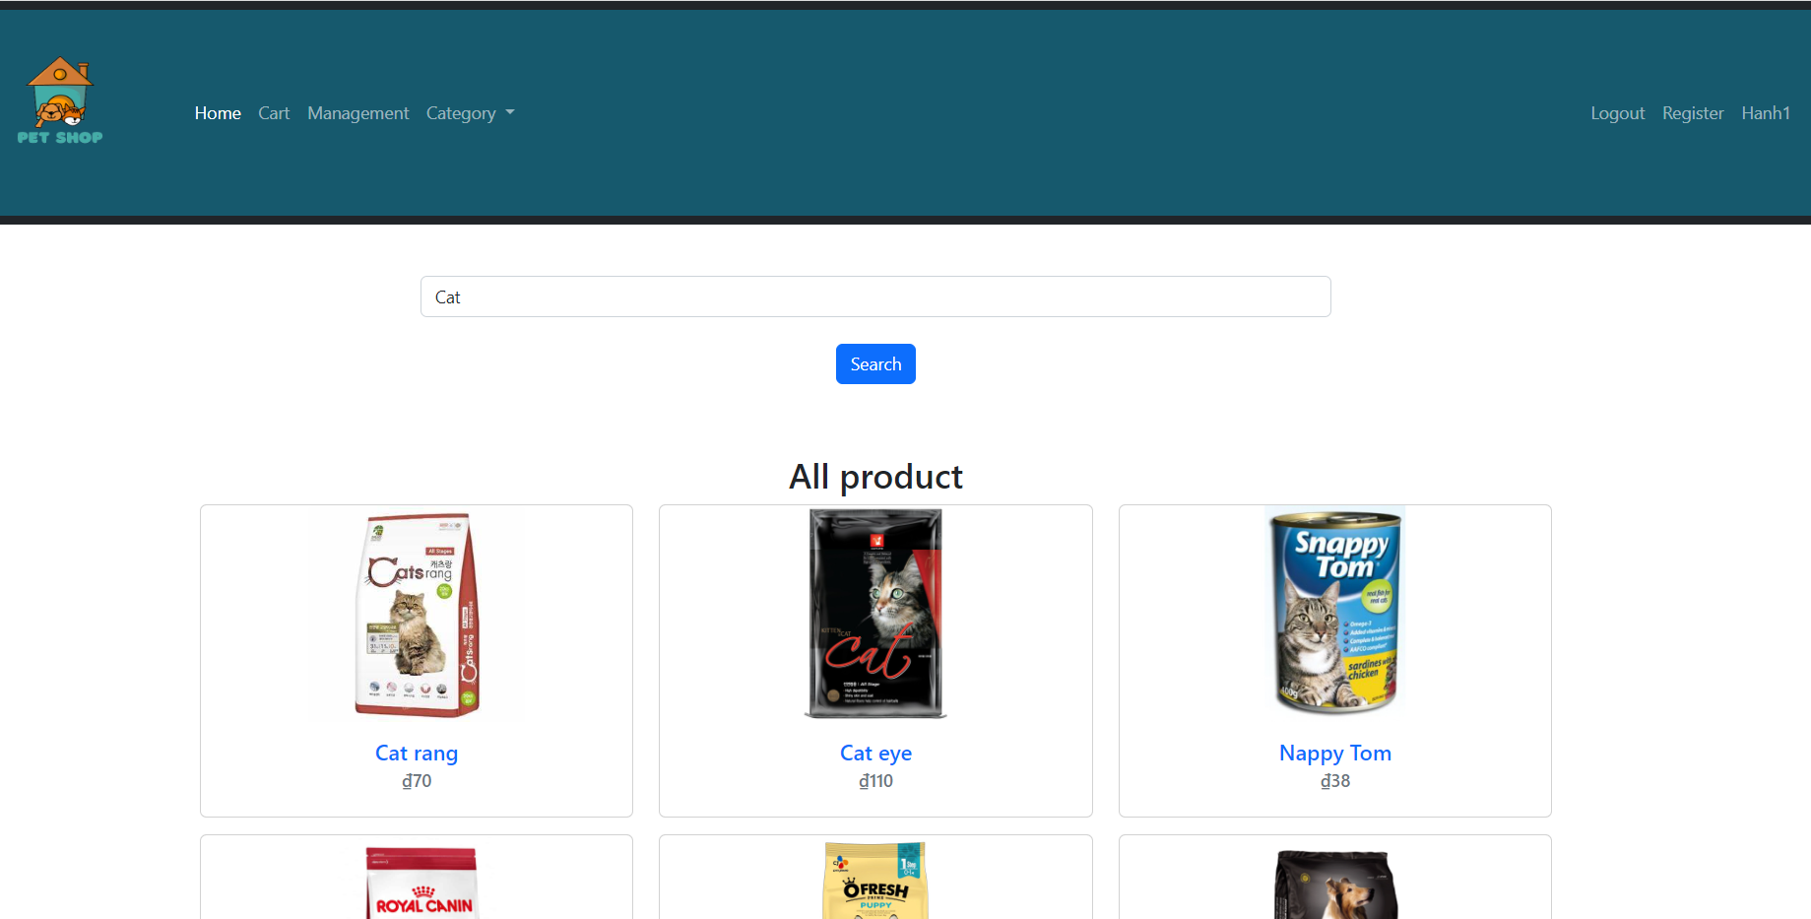

All products will be displayed

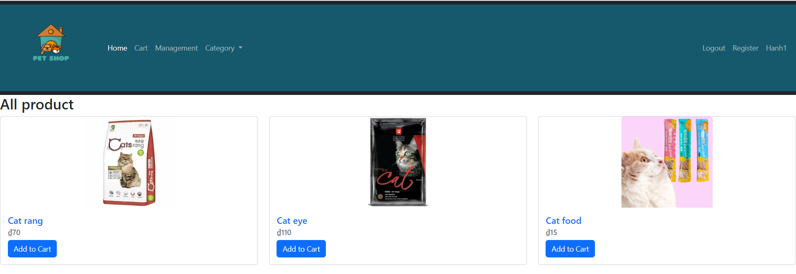

* Category

When user wants to filter by category of each product user can click on the category he wants to see and all products of that category will be displayed.

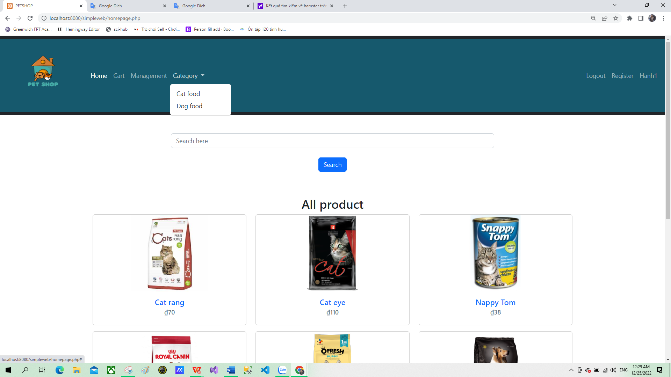

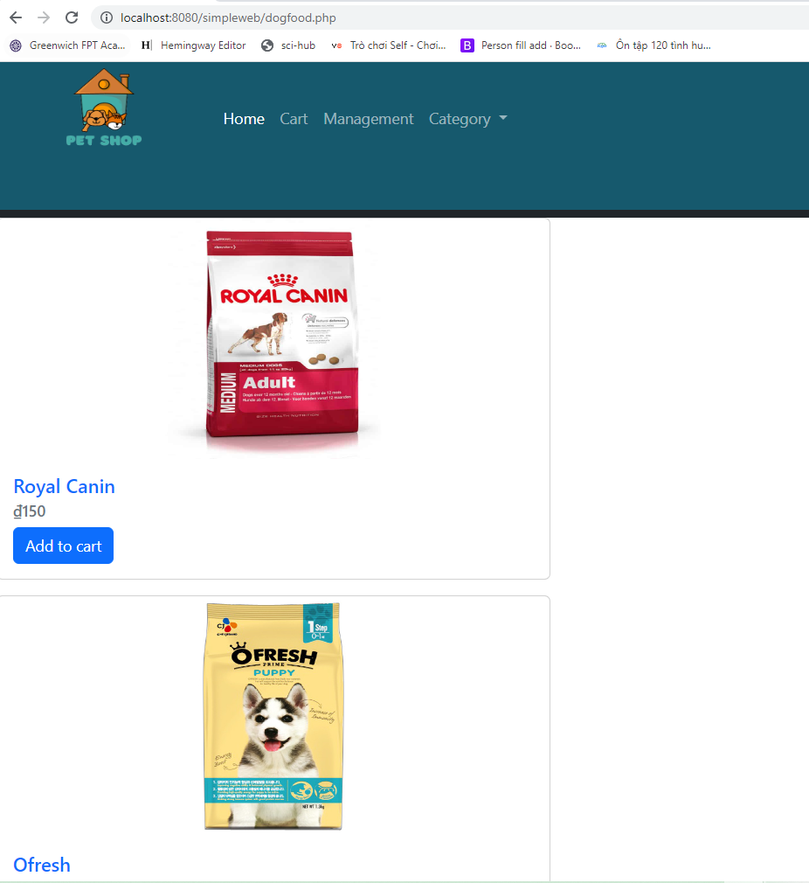

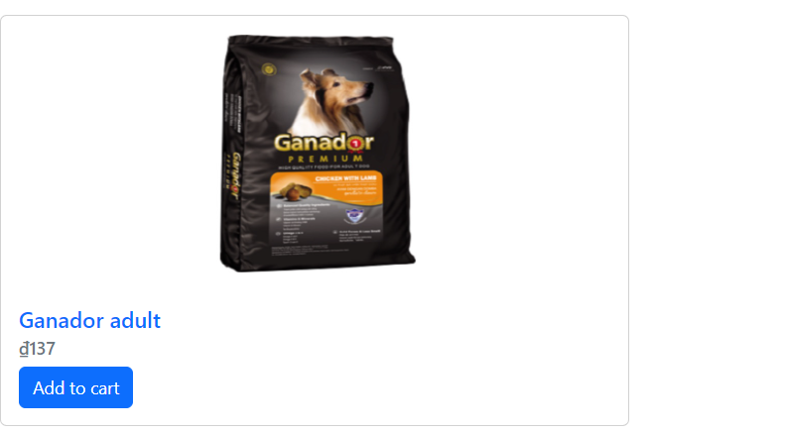

**III. TESTING**

1. **Test plan**

|  |  |  |  |  |  |  |
| --- | --- | --- | --- | --- | --- | --- |
| No. | Test case | Function | Testing data | Expected Output | Expected Output | Expected Output |
| 1 | Verify that user will register successfully when user enters valid information. | Register | Username(*): dai hanh2  Password(*): 11  Confirm Password(*): 11  Phone(*): 1234  Email(*):  dndhanh_203@gmail.com  Gender(*): Female  Birthday(*): 13/12/2003 | When successful  registration, the  website will  display “You have  registered  successfully ". | The website  displays the  message "Congrats!". | Pass |
| 2 | Verify that user “Please fill out this field” message is displayed when user leaves blank with (*) fields. | Register | Username(*):  Password(*): 11  Confirm Password(*): 11  Phone(*): 1234  Email(*):  dndhanh_203@gmail.com  Gender(*): Female  Birthday(*): 13/12/2003 | failed and will display the error line " Please fill out this field” | failed and will display the error line " Please fill out this field” | Pass |
| 3 | Verify that “Password  and Password confirm  can’t match, please  check again.” message is  displayed when user  enters the differences  password and confirm  password | Register | Username(*): dai hanh2  Password(*): 11  Confirm Password(*): 123  Phone(*): 1234  Email(*):  dndhanh_203@gmail.com  Gender(*): Female  Birthday(*): 13/12/2003 | Registration  failed and error  line “Password  and Password  confirm can’t  match, please  check again.” will  display when  user enters  different  password or  different  password  confirm. | The site shows "congrats!" | Fail |
| 4 | Verify that the user has  successfully logged in  with a valid email  and password. | Login | Email: [daihanh@gmail.com](mailto:daihanh@gmail.com)  Password: 123 | When successfully logged in, the website will return to the homepage, the "Login" button will change to the "login name" of that account. | The website return to home page, the “Login” button changes to “ Hanh1”. | Pass |
| 5 | Verify that user login failed and show the error “something wrong with your info “when logged in with invalid account and password. | Login | Email: daihanh@gmail.com  Password: 1234 | Can not login and error line "You logged in failed" will displayed. | Can not login and error line "something wrong with your info" will displayed. | Pass |
| 6 | Verify that user login  failed and error display  "Something wrong with your info" when logging in  without entering a  password. | Login | Email: daihanh@gmail.com  Password: | Can not login and error line  “Enter Password, please”  will be displayed. | Can not login and error line  “Something wrong with your info”  will be displayed. | Pass |
| 7 | Verify that new product  category will be added  successfully when admin  enters valid information | Add product category | Category ID: H03  Category Name: Hamster food | The new product category  will be added and displayed  on the  product category  management page. | The new product category was added and displayed on the product category management page. | Pass |
| 8 | Verify that  "Enter  Category ID, please”  error message is  displayed when category  ID is blank. | Add product category | Category ID:  Category Name: Hamster food | Category  product is not  added and will  display the  error line "Enter  Category ID,  Please ". | Website still adds product category without category ID | Fail |
| 9 | Verify that  "Enter  Category Name, Please”  error message is  displayed when category  name is blank. | Add product category | Category ID: H03  Category Name: | Category  product is not  added and will  display the  error line "Enter  Category Name,  Please ". | Website still adds product category without category Name | Fail |
| 10 | Verify that when the administrator presses the delete button, the "Are you sure you want to delete" is displayed. | Delete product category |  | The website will display the "Are you sure you want to delete" dialog. | The site deletes the product and doesn't show the "are you sure you want to delete" dialog | Fail. |

# References

Agrawal, A., 2019. [Online]   
Available at: https://customerthink.com/top-website-design-and-development-guidelines-for-2019/

Atelierstudios, 2019. [Online]   
Available at: https://atelierstudios.com/web-design-principles/

Canva, 2022. [Online]   
Available at: https://www.canva.com/learn/symmetry-graphic-design/

ComputerHope, 2020. [Online]   
Available at: https://www.computerhope.com/jargon/a/alignment.htm

Greenwich, U. O., 2022. [Online]   
Available at: https://flm.greenwich.edu.vn/DefaultSignin?msg=Thread%20was%20being%20aborted.

Marianne, 2021. [Online]   
Available at: https://www.feelingpeaky.com/9-principles-of-good-web-design/

Martin, S., 2022. [Online]   
Available at: https://web.cs.wpi.edu/~matt/courses/cs563/talks/smartin/int_design.html

Team, W., 2022. [Online]   
Available at: https://www.wallstreetmojo.com/80-20-rule/

Uikit, 2022. [Online]   
Available at: https://uikit.to/what-is-design-consistency-and-how-to-use-them/

W3, 2022. [Online]   
Available at: https://www.w3.org/standards/webdesign/

**Appendix:**

Email: [daihanh@gmail.com](mailto:daihanh@gmail.com)

Password: 123